**Hello Team!** **Consider the below two tables**:

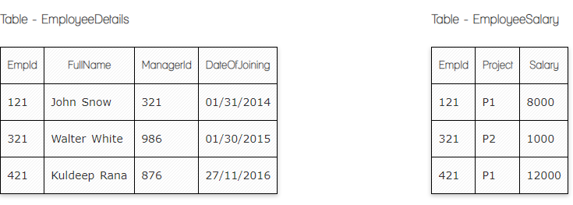

**Ques.1. Write a SQL query to fetch the count of employees working in project 'P1'.**

**Your Answer:**

**SELECT** *Project*, Count (EmpID)  
**FROM** EmployeeSalaray

**Where** Project= ‘P1’

**GROUP BY** Project;

**Ques.2. Write a SQL query to fetch employee names having salary greater than or equal to 5000 and less than or equal 10000.**

**Your Answer:**

**Select** FullName

**From** EmployeeDetails

**Where** Salary Between 5000 and 10000;

**Select** FullName

**From** EmployeeDetails

**LEFTJOIN** EmployeeSalary

**ON** EmployeeDetails.EmpId=EmployeeSalary.EmpId;

**Ques.3. Write a query to fetch employee names and salary records. Return employee details even if the salary record is not present for the employee.**

**Your Answer:**

**Select** EmployeeDETails.FullName, EmployeeSalary.Salary

**From** EmployeeSalary

**LEFTJOIN** EmployeeDetails

**On** EmployeeDetails.EmpId = EmployeeSalary.EmpId;

**Ques.4. Write a SQL query to create an empty table with ‘Test’ name.**

**Your Answer:**

**CREATE TABLE** Test(   
**Column_name1** *NULL*,

**Column_name2**  NULL);

**Ques.5. Write a SQL query to delete an empty table with ‘Test’ name.**

**Your Answer:**

**DROP TABLE Test;**

**Ques.6. Write a SQL query to fetch all the Employees details from EmployeeDetails table who joined in Year 2016.**

**Your Answer:**

**SELECT COUNT**(EmpID), Dateofjoining  
**FROM**  EmployeeDetails  
**GROUP BY** Dateofjoining

**HAVING** COUNT(Dateofjoining) > 2016;

**Ques.7. Write a SQL query to insert new record to the EmployeeDetails table with any data.**

**Your Answer:**

**INSERT INTO** EmployeeDetails (FullName, ManagerId, Dateofjoining )  
**VALUES**  ('Ani', '3', '01/06/2024');

**Ques.8. Write a SQL query to update EmployeeSalery table with setting Salary to 2000 for Project P2.**

**Your Answer:**

**UPDATE** employeeSalary

**SET** Salary = '2000’,   
**WHERE** Project= ‘P2’;

**Ques.9. Write a SQL query to right join both tables.**

**Your Answer:**



**SELECT** EmpDet.EmpId, EmpSal.Project, EmpSal.Salary  
**FROM** EmpSal

**RIGHT JOIN** EmpDet

**ON** EmployeeDetails.EmpID= EmployeeSalary.EmpId;